A1: Research Question

I want to examine the relationship between patients with anxiety and hospital readmission. This has relevance because, if there is indeed a relationship, doctors could give special treatment to those suffering from anxiety in order to reduce their readmission rates, freeing up more resources for the hospital.

A2:Benefits of Question

Analyzing the link between anxiety and readmissions to hospitals helps patients by providing individualized care regimens that lessen stress and enhance overall health outcomes. Healthcare professionals can improve treatment plans and raise patient contentment. Better resource allocation and reduced readmission rates are advantageous to hospitals. Insurance companies save money and have better risk control. By using their knowledge, policymakers may support integrated care models and enhance public health outcomes. Scholars have the chance to generate novel approaches for mitigating readmission rates. Community health organizations have the ability to develop focused interventions and increase mental health's visibility.

A3: Identification of Relevant Variables

For my research question of is there a relationship between patients with anxiety disorders and them being readmitted will need two variables form the medical.csv file. The two variables are,

1. Anxiety (qualitative), row 1 example: 1  
   This column, which is a binary variable, shows whether the patient has anxiety or not.
2. ReAdmis (qualitative), row 1 example: No

This column, which is a binary variable, shows if the patient was readmitted within a month of being released.

B1: Analysis of Variables

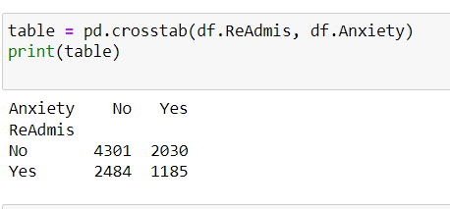

Above are data and summary descriptions of the variables readmission and anxiety.

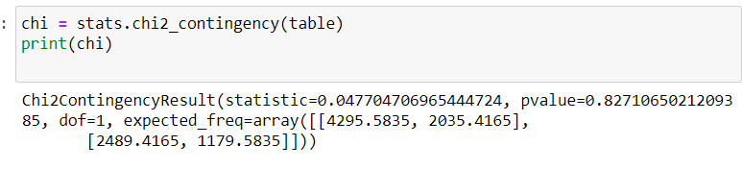

The returned p value from the chi test was approximately .82.

B2:Results of Analysis

This figure represents the likelihood that the null hypothesis will yield the observed result. A p-value below the selected alpha level (.05) signifies a statistically significant outcome from the null hypothesis and the observation and acknowledgement of a meaningful difference between distributions. The.05 alpha number I chose denotes a 95% confidence level that a p value of less than.05 would demonstrate significance. It is evident that the P value, which comes back at.82, is not less than the alpha value of.05. We accept the null hypothesis in light of this. This leads us to the conclusion that, when compared to the distribution of readmitted patients without anxiety, the distribution of patients with anxiety does not differ statistically significantly.

B3. Justification of Analysis Techniques

I was testing to see if there was a statistically significant difference between the proportion of patients readmitted with chronic back pain and those readmitted without it. As was done in this instance, one can determine whether or not two proportions are independent of one another using a chi-square test for independence. The chi-square test was the best option because this data was both discrete (concrete, whole numbers that cannot be quantified more precisely) and categorical in character, even though other tests can be used to get similar conclusions.

C1. Univariate Statistics

Categorical Variables chosen: Marital Status and Number of Children

Continuous Variables chosen: Total Charge and Income

For the distribution of children, you can see majority of the numbers fall in the range of 0-5. The major points were children 01,2,3, and 4. Then the slope begins a deep decline between 5 and 10 children where they have similar amounts reported. The distribution of Patient Marriage status was pretty consistent with close to equal frequency across the 5 different options. I found it surprising that widowed was the highest at 20.5, and divorced was the lowest at 19.6.

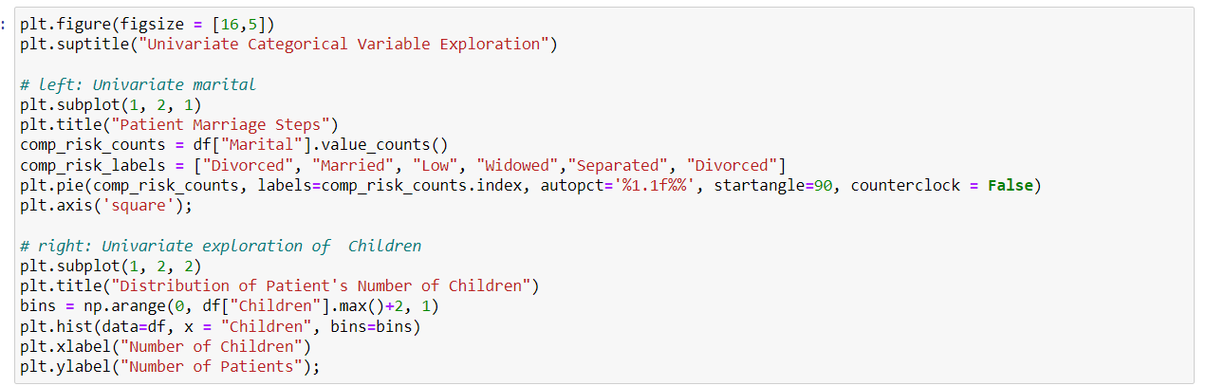

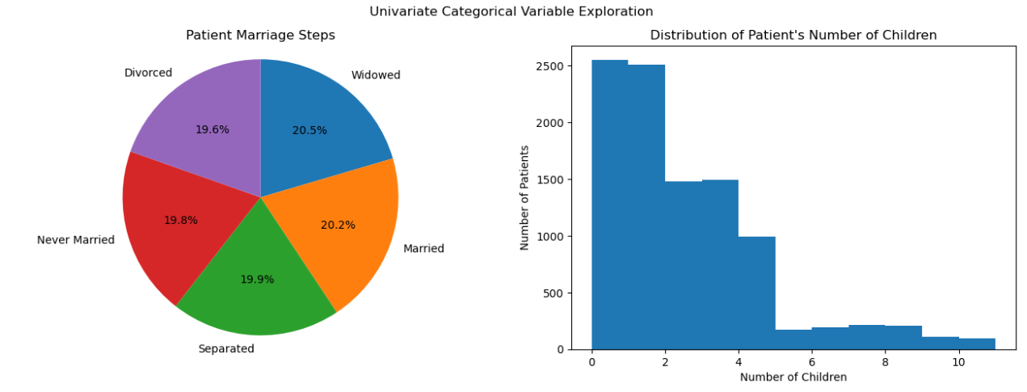

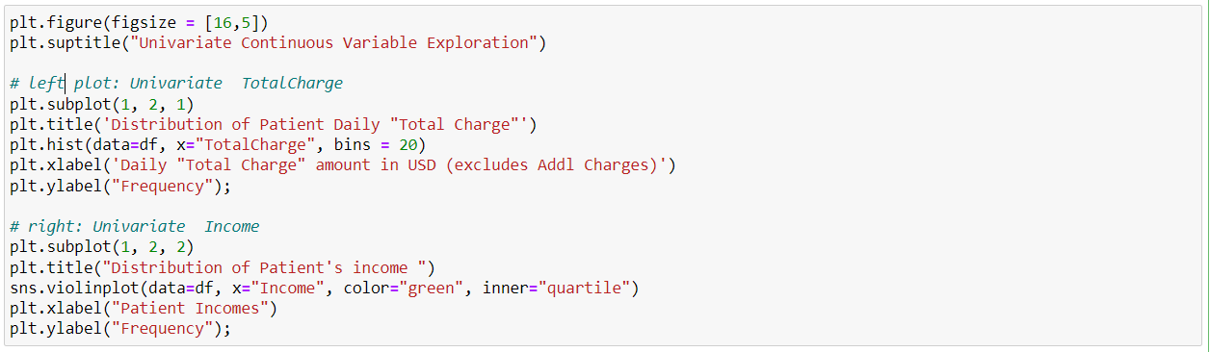

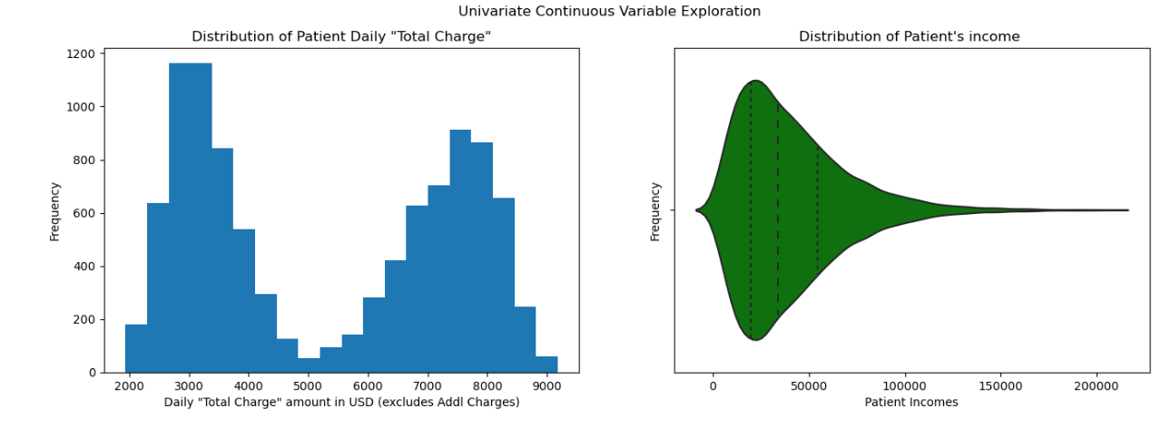

C2: Bivariate Statistics

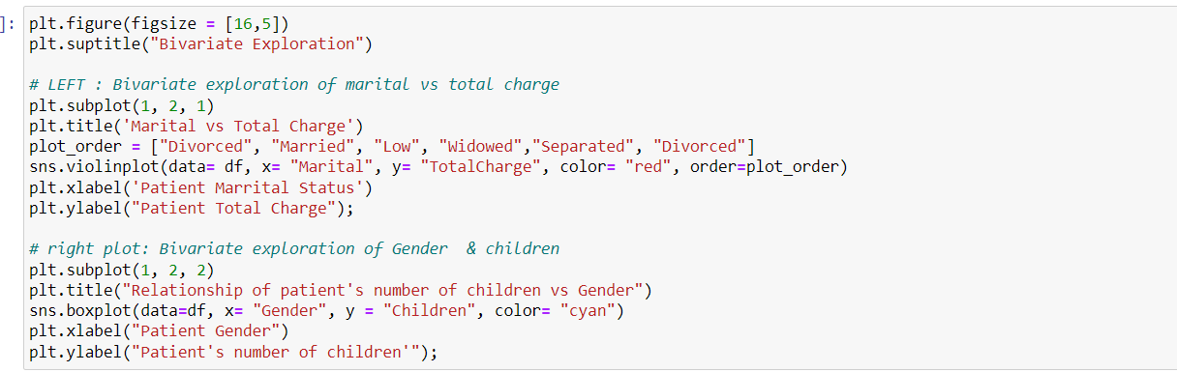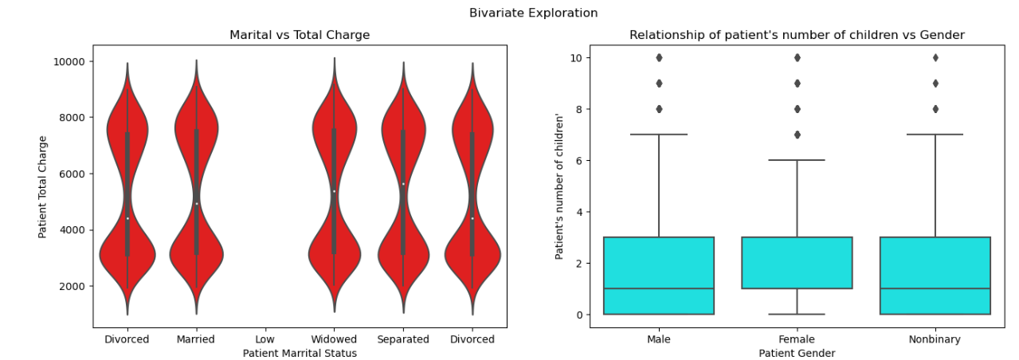

In the violin shaped visuals for marital and total charge, you can see that the shapes are pretty uniform. To note the married patients seemed to have a higher maximum compared to the other marital statuses if you look at the top. The plot on the right that relates to children vs gender, you can see that most of the data ends up being allocated in q1. This is demonstrating a heavily skewed distribution to the left[*Understanding Boxplots*. Built In], and I believe its because the nature of the data and it not being highly common to have more than 3-4 kids in general.

Marital vs total Charge

Number of children vs Gender

E1: Hypothesis Test Results

As seen above, the returned p value from the chi-square test I performed was approximately .83. With this being above the alpha value set at 0.05, it indicates that there is no statistical relationship between the readmission of patients and those patients having anxiety or an anxiety disorder. IF the p value was below .05, it would signify with 95% certainty that there is indeed a relationship between readmission of patients and patients having anxiety or anxiety disorders. Given the results of the analysis conducted, the null hypothesis is accepted.

E2: Limitations of Analysis

This is a finite population size that wasn’t fully populated and had to be cleaned up inorder to do analysis. I believe that would indicate that this data wasn’t collected through the best methods and does leave some speculation. For example, different results would have been obtained if the dataset had been larger and correctly filled out with consistent and accurate information, as this would have an impact on the standard deviation of any distribution of readmission rates.

E3: Recommended Action

Despite the lack of a substantial correlation between anxiety and readmission rates in my analysis, it makes sense to keep gathering and logging this data. Continuous data collection is an investment well worth making because of the possible advantages, which include investigating intricate relationships, carrying out longitudinal studies, adjusting to changing healthcare situations, and facilitating well-informed decision-making.

Code + Source References

Python conducted the Chi-square test for independence using SciPy's chi2_contingency function.

I was given instructions by WGU Courseware Resources on how to do a chi-square test on a contingency table.

I was given instructions by WGU Courseware Resources on how to do a chi-square test on a contingency table.

*Understanding Boxplots*. Built In. (n.d.). https://builtin.com/data-science/boxplot